**CHAPTER 01**

**INTRODUCTION**

The Indian government provides number of food stuffs to their citizens in miserable rates to full fill the requirement of food in remote areas also, toprovide the wealth and to eradicate famine starvation. An official document provided by the state governments in India to the families that are eligible to purchase food grains at subsidized rates.

These food grains are delivered to the families with the help of PDS (public Distribution system)

There are three types of ration cards issued by the government are :

1. APL (Above Poverty Line )
2. BPL (Below poverty Line )
3. AAY (Antyodaya)

These are provided by the priority, defined by the National Food Security Act[4]. There are many problems with conventional PDS systems like millions of ineligible and fraud ration cards gets the benefits; at the same time there are many poor families having no Ration Cards.

Shop owners divert rationing grains to open market. To overcome such frauds and black market practices. We have designed Electronic Ration Card with Finger Print Authentication.

In this project work, we have to take the fingerprints of every member of ration card holder family. By collecting this data we can monitor the need of food grains of every family according to number of family members. By using this huge collection of data, we can call it as a big data we can analyze the need of grains and other food stuffs of the nation and according to this we can import or export the agricultural outcomes. The data we have gathered can be used to implement number of policies and schemes to eradicate the poverty.

**CHAPTER 02**

**LITERATUCHER SERVEY**

[1] Peter Svedberg; “Reforming or Replacing the Public distribution system with cash transfers”, October 2012,

In this literatucher servey author focuses on the cash transfer scheme having a deeper political motivation while making it clear that the economic growth will in constant and transparent. While discussing the shortfalls of UID and Aadhar as a form of identity this may lead to misuse of privacy policies. This we help in reduction of poverty and freedom to purchase any food stuff from wherever the citizens want. This provides an satisfaction among the peoples of India.

[2] Rajneesh Mahajan, ” Bar-coded Ration card public distribution system”13th July 2012.

This literature survey has an best solution to overcome corruption. We can apply E-government to introduce transparency in the system and to fulfill the basic needs of citizens at very low cost with the help of public distribution system. Public Distribution system is the largest Government economic policy in India.

[3] Hemand Sharma, “UID and PDS system”, December 2012.

Public distribution system is an Indian food security system with a network of around 5 lakh. Fair Price shops are the largest retail system in the world. The main problem associated with this system is robbery of grains from the essential commodities without their knowledge. The traditional public distribution system today supports over 45 crores Indian BPL with monthly supply of subsidized food grains. The food grain doesn’t reach the intended people. This problem can be solved by using E-Ration card.

[4 S.Valarmathy,R.Ramani,Fahim Akhatar, “Automatic Ration Material Distribution based on RFID Technology”.

This system uses GSM and RFID,to avail the benefit of government user has to scan the code using the reader to fetch the details of items allocated to user ,and then the microcontroller of system checks user’s details and quantity allocated to user .The amount details are shown after receiving order,controller sends the information to authorities and customer through GSM technology.

[5] Authors:Yogesh Kumar Sharma,K B Shiva Kumar “Multi-Modality Biometric Assisted Smart card Based Ration Distribution system”. It uses technique of fingerprint scanning as well as face detection. The database stores the records of users purchase history. They use a centralized cloud system so that transparency is maintained and users can access their details of record at some other fair price shop.

[6] Authors: Shivabhakt Hanamant,Suraj V.S.Moresh Mukhedkar.“Atomization of Rationing System”.

It proposes atomization of distribution system at the ration shop as well as maintaining the database at one main control station and updating the database so that the shopkeeper cannot cheat the people. The tags are used for authentication of valid users. For updating GSM is used.

[7] Authors:SKanagasubaraja,K.Arul Ganesh,Mohesh Viswas. “Biometric Device using Smart Card in public Distributed system”

It proposes system using smartcards for all the citizens. The smartcard contains the details of the citizen. Citizen can view the total quantity of the stock available. After each and every transactions the stock get reduced in board and the citizen receives the sms and email from government with the purchased time and number of products bought with the product id and also uploaded in the main database then and there. The cards are verified based on the citizen’s fingerprint. To check whether he is smartcard holder, each and every person’s fingerprint in a family are collected during card requesting and according items are allocated.

CHAPTER 03

SYSTEM SPECIFICATION

KEY SPECIFICATIONS

|  |  |
| --- | --- |
| Pixel resolution | 512 dpi (average x, y over the scan area) |
| Scan capture area | 14.6 mm (nom. width at center) 18.1 mm (nom. length) |
| 8-bit grayscale | 256 levels of gray |
| Reader size (approximate) | 65 mm x 36 mm x 15.56 mm |
| Compatibility | USB 1.0, 1.1 and 2.0 (Full Speed) |

RATINGS

|  |  |
| --- | --- |
| Supply Voltage | 5.0V ±5% supplied by USB |
| Supply Current (scanning) | < 100 mA (Typical) |
| Supply Current—idle mode | 120 mA (Typical) |
| Supply Current—suspend mode | < 0.5 mA (Maximum) |
| ESD Susceptibility | >15 kV, mounted in case |
| Temperature, Operating | 0 - 40 C |
| Humidity, Storage | 20% - 90% non-condensing |
| Scan Data | 8-bit grayscale |
| Standards Compliance | FCC Class B, CE, ICES, BSMI, MIC, USB, WHQL |
| Weight | 105 grams |
| Interface | USB 2.0 Full-speed High Power Device |

Mechanical Specifications

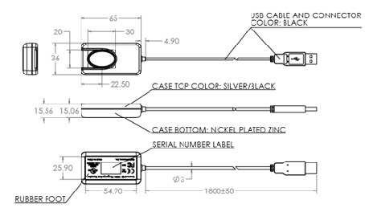

**Figure 3.1.1** **Mechanical Specification of Scanner**

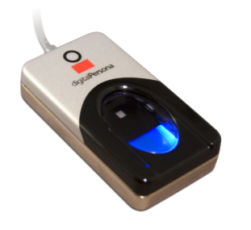

**Figure 3.1.2 Digital Persona 4500**

**PRODUCT DESCRIPTION**

The U. are. U 4500 Fingerprint Reader is a USB peripheral perfect for individual desk top users, as well as multiple users in shared environments. Its compact design conserves desk space in enterprises, and its professional, modern appearance looks elegant in point-of-sale environments. The U. are. U 4500 Reader utilizes optical fingerprint scanning technology to achieve excellent image quality, a large capture area and superior reliability. A silicone coating allows it to read a wide range of fingerprints accurately and rapidly regardless of placement angle. The high-quality metal casing resists unintentional movement.

To use, simply place a finger on the reader window and the reader quickly and automatically captures and encrypts the fingerprint image before sending it to the Digital Persona® Finger jet ™ biometric engine for verification. For superior user feedback, a red “flash” indicates that a fingerprint image has been captured.

The U. is. U 4500 Fingerprint Reader is designed for use with a full range of Cross match™ software including our authentication solutions, as well as most of our U. are. U Software Development Kits. Whether you are an enterprise customer or a system integrator, Cross match’s biometric identity verification solutions provide a natural extension to your security system and applications.

Chapter 04

Block Diagram/ Description

The general block diagram here drowned can explain overall system; it can be summarized as given below:

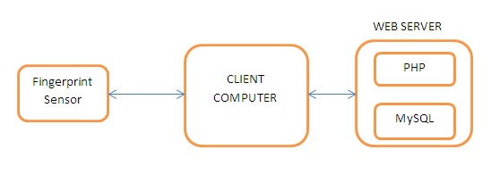

**Figure 4.1.1 System Architecture**

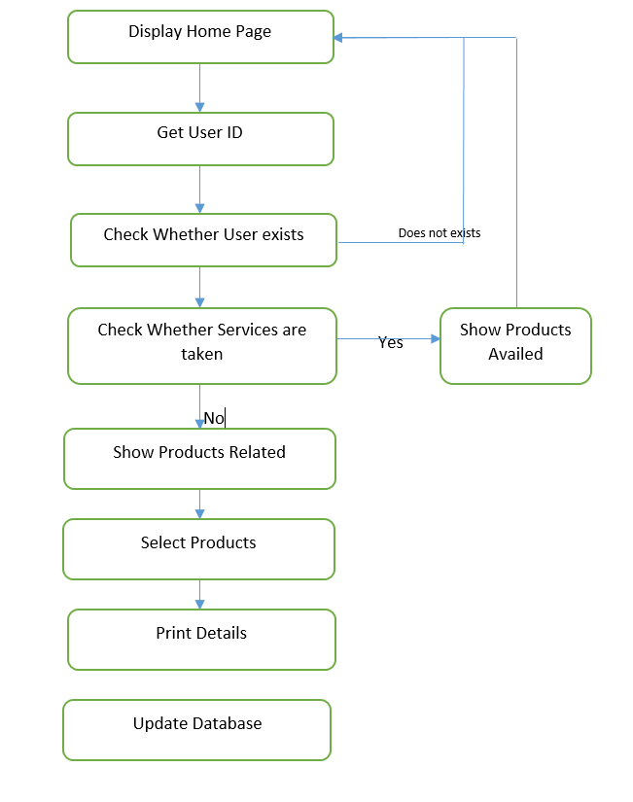

**Figure 4.1.2 Program Algorithm**

Fingerprint scanners:

By using this biometric tool, the main aim is to identify every person uniquely. As every human has a unique finger print pattern. As these fingerprints cannot be altered, they are specific to only one person.

There are four types of fingerprint scanners:

1. Capacitance scanner.
2. Optical scanner.
3. Ultrasonic fingerprint scanner
4. Thermal scanners.

We have used Optical Scanner which captures photos using digital camera and matches with the one in database, by comparing two instances of skin impression. Fingerprint identification is also known as Dactyloscopy.

We have designed two systems required for the better efficiency

1. Administrator.
2. Distributor.

We have designed separately both the systems Administrator and Distributor respectively

Let us see one by one

1. Administrator

In this project there are two systems one Administrator and Distributor. Administrator section is used for addition/removal, updating user details and granting services. Distributor section is used for availing the services with fingerprint authentication system.

A user first provides his/her family identification number based on this, respected family details are shown on the screen with all family member details using this any one member can avail services for the family.

The users fingerprint along with family details like total family members and poverty line details. These details are stored in the database and services are sorted based on poverty line.

The end user can only avails the services after verification of the fingerprint with the one stored in the database hence preventing frauds from the dealers.

2. Distributor

In this project there are two systems one Administrator and Distributor. Administrator section is used for addition/removal, updating user details and granting services. Distributor section is used for availing the services with fingerprint authentication system.

A user first provides his/her family identification number based on this, respected family details are shown on the screen with all family member details using this any one member can avail services for the family.

Traditionally State government of India provides a hard copy of Ration card. This approach has led to malpractices by the owners of PDS shops. Hence to overcome this this system uses online biometric verification of the end user.

The users fingerprint along with family details like total family members and poverty line details. These details are stored in the database and services are sorted based on poverty line.

The end user can only avails the services after verification of the fingerprint with the one stored in the database hence preventing frauds from the dealers.

This system is equipped with Digital Persona 4500 fingerprint scanner. It is a high performance optical scanner with 512dpi pixel resolution; 14.6mm scan capture area, 8bit grayscale, 65mm x 36mm x 15.56mm reader size.

**Chapter 05**

**Circuit Diagram**

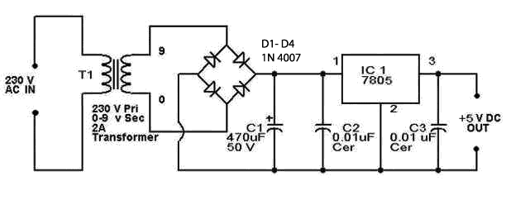

**Figure 5.1.15 Regulated Power Supply**

A powersupply is an electrical device which supplies [power](https://en.wikipedia.org/wiki/Electric_power) in the form electric. The primary work of a power supply is to convert [electric current](https://en.wikipedia.org/wiki/Electric_current)  to [voltage](https://en.wikipedia.org/wiki/Voltage), [current](https://en.wikipedia.org/wiki/Electric_current), and [frequency](https://en.wikipedia.org/wiki/Frequency) to power the load. As the result of power supplies is most of time referring to as [electric power converters](https://en.wikipedia.org/wiki/Electric_power_converter). Some power supplies has separate standalone pieces of equipment, while others are built into the load appliances. For example power supply found in number of personal computers and [their electronics](https://en.wikipedia.org/wiki/Consumer_electronics) devices. Another functions of power supply may perform include limiting the current which is drawn by the load to safe levels, shutting off the current in the event of an [electrical fault](https://en.wikipedia.org/wiki/Electrical_fault), power conditioning to prevent [electronic noise](https://en.wikipedia.org/wiki/Electronic_noise) on the input from  [power-factor correction](https://en.wikipedia.org/wiki/Power-factor_correction), and storing energy. So it can continue to power the load in the event of a temporary interruption in the source power.

All power supplies have a powerinput connection, which receives energy in the form of electric current from a source, and poweroutput connections that deliver current to the load. The source power may come from the [electric power grid](https://en.wikipedia.org/wiki/Electric_power_grid), such as an [electrical outlet](https://en.wikipedia.org/wiki/Electrical_outlet), [energy storage](https://en.wikipedia.org/wiki/Energy_storage) devices such as [batteries](https://en.wikipedia.org/wiki/Battery_(electricity)) or [fuel cells](https://en.wikipedia.org/wiki/Fuel_cell), [generators](https://en.wikipedia.org/wiki/Electrical_generators) or [alternators](https://en.wikipedia.org/wiki/Alternator), [solar power](https://en.wikipedia.org/wiki/Solar_power) converters, or another power supply. The input and output are usually hardwired circuit connections, though some power supplies employ [wireless energy transfer](https://en.wikipedia.org/wiki/Wireless_power) to power their loads without wired connections. Some power supplies have other types of inputs and outputs as well, for functions such as external monitoring and control.

There are three different types of power supplies,

1. Unregulated
2. Linear regulated
3. Switching

We have designed linear regulated power supply. The main of designing power supply is to provide 5V DC power to the finger print scanner which is Digital Persona 4500.

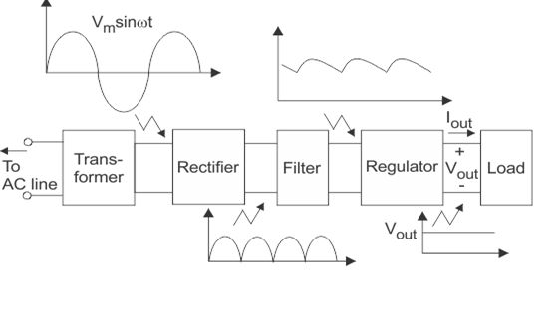 **Figure 5.1.2 Regulated Power Supply**

The power supply is one of the most important components of a computer. It is needed to convert the AC current from the wall socket to the DC current used by the other components of the computer. Alternating current (AC) is a type of electricity in which the electrons switch directions while transmitting. It is used for transmitting larger amounts of electricity over long distances, and it is the type of electricity that comes out of a wall socket. Direct current (DC) is needed to power electronic systems such as the components inside of a computer.

* There are three different types of power supplies, unregulated, linear regulated, and switching.

In unregulated power supplies, there are a lot of AC properties such as ripple voltage carrying over to the DC power where it is not needed, but it is a cheap and efficient option for a power supply. Ripple voltage can be a problem because it causes the voltage to be inconsistent. When the hardware that the power supply powers requires a consistent DC charge. so the device doesn't receive the intended type of voltage, which can possibly shorten the lifetime of some parts.

A linear regulated power supply is just like an unregulated one except for a transistor circuit that that operates in linear mode. The linear regulator outputs a fixed voltage for a wide range of inputs, effectively getting rid of excess voltage from the input. The problem with linear regulated power supplies is that all the excess voltage that is dropped results in a dissipation of heat, causing the power supply to require large heat sinks which ultimately make them expensive and inefficient.

The third type of power supply is switching. It operates by converting incoming AC current into DC, reconverting it into high frequency AC, using a transformer to step the voltage up or down, and finally turning the charge back into DC and filtering for final output. There are many advantages to using switching power supplies, such as being universal (able to power other electric power systems), light weight, and highly efficient. There are some disadvantages however, as they are very complex, can still have ripple voltage in their outputs (in cheaper models), and are expensive.

All power supplies have a powerinput connection, which receives energy in the form of electric current from a source, and poweroutput connections that deliver current to the load. The source power may come from the [electric power grid](https://en.wikipedia.org/wiki/Electric_power_grid), such as an [electrical outlet](https://en.wikipedia.org/wiki/Electrical_outlet), [energy storage](https://en.wikipedia.org/wiki/Energy_storage) devices such as [batteries](https://en.wikipedia.org/wiki/Battery_(electricity)) or [fuel cells](https://en.wikipedia.org/wiki/Fuel_cell), [generators](https://en.wikipedia.org/wiki/Electrical_generators) or [alternators](https://en.wikipedia.org/wiki/Alternator), [solar power](https://en.wikipedia.org/wiki/Solar_power) converters, or another power supply. The input and output are usually hardwired circuit connections, though some power supplies employ [wireless energy transfer](https://en.wikipedia.org/wiki/Wireless_power) to power their loads without wired connections. Some power supplies have other types of inputs and outputs as well, for functions such as external monitoring and control.

**Chapter 06**

**System Design**

**Problem Statement:**

Design 5V regulated DC power supply

Solution:

The power supply is one of the most important components of a computer. It is needed to convert the AC current from the wall socket to the DC current used by the other components of the computer. Alternating current (AC) is a type of electricity in which the electrons switch directions while transmitting. It is used for transmitting larger amounts of electricity over long distances, and it is the type of electricity that comes out of a wall socket. Direct current (DC) is needed to power electronic systems such as the components inside of a computer.

* There are three different types of power supplies, unregulated, linear regulated, and switching.
* We have designed regulated power supply of 5V DC power.



**Figure 6.1.2 Design of power supply**

**Working:**

Steps to design the power supply:

1. Determine the total current that the system sinks from the supply.
2. Determine the voltage rating required for the different components.
3. The bridge rectifier and capacitor input filter produce an unregulated dc voltage which is applied at the input of 7805.
4. The minimum dropout voltage is 2v for IC 7805,the voltage applied at the input of terminal should be at least of 7v.
5. C1 may be of 1000uf/65v is the filter capacitor.
6. C2,C4 will be 0.1uf ceramic,C3 will be the 220uf/25v electrolyte capacitor is connected across the regulator to improve the trisent response of regelator.
7. Assuming the drop out voltage is 2v,the min imum dc voltage across the capacitor c1 should be equal to 7v.

So,

Vdc=5+2=7v

So at the regulator input minimum 7v should be applied

According to formula,

Vdc=2Vm/pi.

Assuming there is no ripple factor,

So,

Vm=Vdc.pi/2

=7*3014/2

=10.99v

During one cycle,two diode are conducting ,hence

Vr=2(Vim-Vdc)

=2(12.39-7)

=10.78v

C=Vdc/(F*R*Vr)

=7/(100*17.510.78)

=371.05uf

So for the safe working we select capacitor of 1000uf.

C=1000uf/35v

C1=1000uf/35v electrolytic capacitor

C2,C4= 0.1uf ceramic capacitor

C3=220uf/25v electrolytic capacitor.

Drop of voltage of one diode is 0.7v.

Drop of voltage of second diode is 1.4v.

Vim=Vm+1.4

=10.99+1.4

12.39v

Vrms=Vim/sqrt[2]

=8.67

Vim=12.39v

Vrms=8.76v

So we select transformer of 9v

Im=Idc*pi/2

=400m*3.14/2

=628m

Irms=Im/sqrt[2]

=628m/sqrt[2]

=444.06mA

So we select the transformer current rating 500mA.

So, considering voltage and current of transformer rating 0-9v/500m A step down transformer.

Rectifier design:

PIV of diode=Vm=12.39v

Im=628mA

So we select the bridge IC of 1 A rating.

Filter capacitor design:

R=Vdc/Idc

=7/400m

=17.5ohm

So for the safe working we select capacitor of 1000uf.

C=1000uf/35v

C1=1000uf/35v electrolytic capacitor

C2,C4= 0.1uf ceramic capacitor

C3=220uf/25v electrolytic capacitor.

**SPECIFICATION**:

The suitability of a particular power supply for an application is determined by various attributes of the power supply .Commonly specified attributes for a power supply include:

* Type of Input voltage AC or DC and range.
* Efficiency of power conversion.
* The amount of [voltage](https://en.wikipedia.org/wiki/Voltage) and [current](https://en.wikipedia.org/wiki/Current_(electricity))  supplied by power supply to its load
* Accuracy in output of power supply.
* Stability of output voltage and current which goes on under varying line and load conditions.
* How long it can supply energy without refueling or recharging.
* Operating and storage temperature ranges.

**Chapter 07**

**Software development**

We have designed web server which consist of two types of databases

1. PHP
2. MySQL

MySQL is structured query language which is used to handle huge amount of data bases in particular sequence and it is developed by Microsoft.

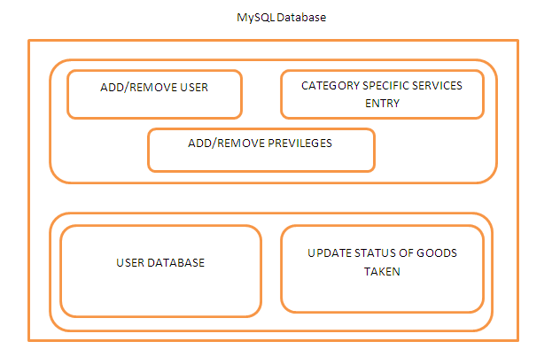

**Figure 7.1.1 MySQL Database**

In this project there are two systems one Administrator and Distributor. Administrator section is used for addition/removal, updating user details and granting services. Distributor section is used for availing the services with fingerprint authentication system.

A user first provides his/her family identification number based on this, respected family details are shown on the screen with all family member details using this any one member can avail services for the family.

**A. Web Server**

This system works with dynamic databases and is stored in a web server for that we have used XAMPP Server. It holds all the required software and web configurations required for the communication between Administrator server and Distributor PC.

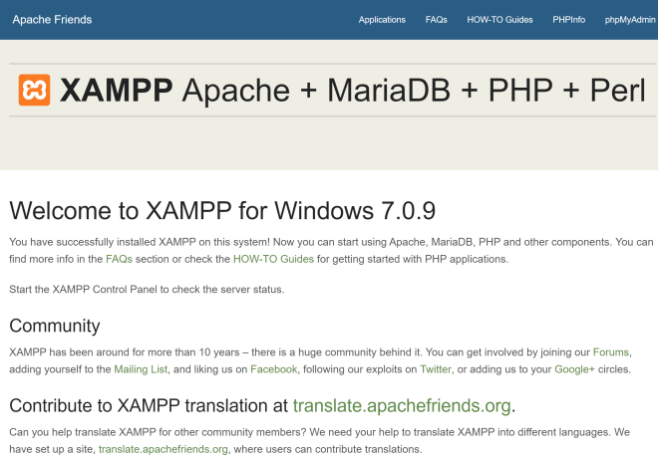

**Fig 7.1.2.XAMPP Server**

In this project there are two systems one Administrator and Distributor. Administrator section is used for addition/removal, updating user details and granting services. Distributor section is used for availing the services with fingerprint authentication system.

A user first provides his/her family identification number based on this, respected family details are shown on the screen with all family member details using this any one member can avail services for the family.

**B. Database**

For storing user’s data and fingerprint details this system uses a MySQL Database in our system. This contains all the required tables for storing the user’s information and fingerprint data.

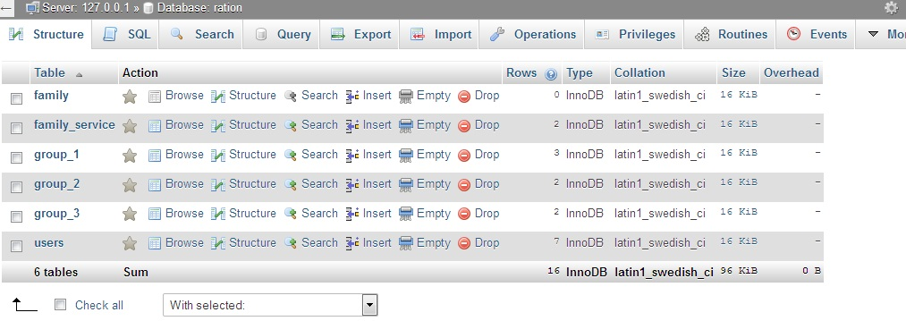

**Fig 7.1.3 Database**

Coding Part:

-- MySQL dump 10.16 Distrait 10.1.21-MariaDB, for Win32 (AMD64)

--

-- Host: localhost Database: localhost

-- ------------------------------------------------------

-- Server version 10.1.21-MariaDB

/*!40101 SET @OLD_CHARACTER_SET_CLIENT=@@CHARACTER_SET_CLIENT */;

/*!40101 SET @OLD_CHARACTER_SET_RESULTS=@@CHARACTER_SET_RESULTS */;

/*!40101 SET @OLD_COLLATION_CONNECTION=@@COLLATION_CONNECTION */;

/*!40101 SET NAMES utf8 */;

/*!40103 SET @OLD_TIME_ZONE=@@TIME_ZONE */;

/*!40103 SET TIME_ZONE='+00:00' */;

/*!40014 SET @OLD_UNIQUE_CHECKS=@@UNIQUE_CHECKS, UNIQUE_CHECKS=0 */;

/*!40014 SET @OLD_FOREIGN_KEY_CHECKS=@@FOREIGN_KEY_CHECKS, FOREIGN_KEY_CHECKS=0 */;

/*!40101 SET @OLD_SQL_MODE=@@SQL_MODE, SQL_MODE='NO_AUTO_VALUE_ON_ZERO' */;

/*!40111 SET @OLD_SQL_NOTES=@@SQL_NOTES, SQL_NOTES=0 */;

--

-- Table structure for table `family`

--

DROP TABLE IF EXISTS `family`;

/*!40101 SET @saved_cs_client = @@character_set_client */;

/*!40101 SET character_set_client = utf8 */;

CREATE TABLE `family` (

`id` int(11) NOT NULL AUTO_INCREMENT,

`family_no` smallint(6) DEFAULT NULL,

`user_lst_1` varchar(25) DEFAULT NULL,

`user_lst_2` varchar(25) DEFAULT NULL,

`user_lst_3` varchar(25) DEFAULT NULL,

`user_lst_4` varchar(25) DEFAULT NULL,

`user_lst_5` varchar(25) DEFAULT NULL,

`user_lst_6` varchar(25) DEFAULT NULL,

PRIMARY KEY (`id`)

) ENGINE=InnoDB DEFAULT CHARSET=latin1;

/*!40101 SET character_set_client = @saved_cs_client */;

--

-- Dumping data for table `family`

--

LOCK TABLES `family` WRITE;

/*!40000 ALTER TABLE `family` DISABLE KEYS */;

/*!40000 ALTER TABLE `family` ENABLE KEYS */;

UNLOCK TABLES;

--

-- Table structure for table `family_service`

--

DROP TABLE IF EXISTS `family_service`;

/*!40101 SET @saved_cs_client = @@character_set_client */;

/*!40101 SET character_set_client = utf8 */;

CREATE TABLE `family_service` (

`family_no` smallint(6) NOT NULL,

`service` enum('0','1') DEFAULT '0',

PRIMARY KEY (`family_no`)

) ENGINE=InnoDB DEFAULT CHARSET=latin1;

/*!40101 SET character_set_client = @saved_cs_client */;

--

-- Dumping data for table `family_service`

--

LOCK TABLES `family_service` WRITE;

/*!40000 ALTER TABLE `family_service` DISABLE KEYS */;

INSERT INTO `family_service` VALUES (1,'0'),(2,'1');

/*!40000 ALTER TABLE `family_service` ENABLE KEYS */;

UNLOCK TABLES;

--

-- Table structure for table `group_1`

--

DROP TABLE IF EXISTS `group_1`;

/*!40101 SET @saved_cs_client = @@character_set_client */;

/*!40101 SET character_set_client = utf8 */;

CREATE TABLE `group_1` (

`name` varchar(25) DEFAULT NULL,

`quantity` smallint(6) DEFAULT NULL,

`prise` smallint(6) DEFAULT NULL

) ENGINE=InnoDB DEFAULT CHARSET=latin1;

/*!40101 SET character_set_client = @saved_cs_client */;

--

-- Dumping data for table `group_1`

--

LOCK TABLES `group_1` WRITE;

/*!40000 ALTER TABLE `group_1` DISABLE KEYS */;

INSERT INTO `group_1` VALUES ('Rice',5,20),('Rice',5,20),('Bajra',5,25);

/*!40000 ALTER TABLE `group_1` ENABLE KEYS */;

UNLOCK TABLES;

--

-- Table structure for table `group_2`

--

DROP TABLE IF EXISTS `group_2`;

/*!40101 SET @saved_cs_client = @@character_set_client */;

/*!40101 SET character_set_client = utf8 */;

CREATE TABLE `group_2` (

`name` varchar(25) DEFAULT NULL,

`quantity` smallint(6) DEFAULT NULL,

`prise` smallint(6) DEFAULT NULL

) ENGINE=InnoDB DEFAULT CHARSET=latin1;

/*!40101 SET character_set_client = @saved_cs_client */;

--

-- Dumping data for table `group_2`

--

LOCK TABLES `group_2` WRITE;

/*!40000 ALTER TABLE `group_2` DISABLE KEYS */;

INSERT INTO `group_2` VALUES ('Rice',20,15),('Bajra',7,15);

/*!40000 ALTER TABLE `group_2` ENABLE KEYS */;

UNLOCK TABLES;

--

-- Table structure for table `group_3`

--

DROP TABLE IF EXISTS `group_3`;

/*!40101 SET @saved_cs_client = @@character_set_client */;

/*!40101 SET character_set_client = utf8 */;

CREATE TABLE `group_3` (

`name` varchar(25) DEFAULT NULL,

`quantity` smallint(6) DEFAULT NULL,

`prise` smallint(6) DEFAULT NULL

) ENGINE=InnoDB DEFAULT CHARSET=latin1;

/*!40101 SET character_set_client = @saved_cs_client */;

--

-- Dumping data for table `group_3`

--

LOCK TABLES `group_3` WRITE;

/*!40000 ALTER TABLE `group_3` DISABLE KEYS */;

INSERT INTO `group_3` VALUES ('Rice',30,10),('Rice',30,10);

/*!40000 ALTER TABLE `group_3` ENABLE KEYS */;

UNLOCK TABLES;

--

-- Table structure for table `users`

--

DROP TABLE IF EXISTS `users`;

/*!40101 SET @saved_cs_client = @@character_set_client */;

/*!40101 SET character_set_client = utf8 */;

CREATE TABLE `users` (

`id` int(11) NOT NULL AUTO_INCREMENT,

`rf_id` varchar(25) NOT NULL,

`family_no` smallint(6) DEFAULT NULL,

`aadhar_no` varchar(25) NOT NULL,

`name` varchar(25) NOT NULL,

`surname` varchar(25) NOT NULL,

`category` enum('1','2','3') DEFAULT NULL,

PRIMARY KEY (`id`)

) ENGINE=InnoDB AUTO_INCREMENT=17 DEFAULT CHARSET=latin1;

/*!40101 SET character_set_client = @saved_cs_client */;

--

-- Dumping data for table `users`

--

LOCK TABLES `users` WRITE;

/*!40000 ALTER TABLE `users` DISABLE KEYS */;

INSERT INTO `users` VALUES (10,'1',1,'9881490550','Papayya','Bhosale','1'),(11,'1',1,'9922617801','Radha','Kullari','1'),(12,'1',1,'9922617801','Ramanjel','Bhosale','1'),(13,'1',1,'9922617802','Aruna','Bhosale','1'),(14,'1',1,'9922617802','Aruna','Bhosale','1'),(15,'2',2,'8180027167','Shrinath','Mediboyan','2'),(16,'2',2,'8180027168','Lakshmi','Mediboyana','1');

/*!40000 ALTER TABLE `users` ENABLE KEYS */;

UNLOCK TABLES;

/*!40103 SET TIME_ZONE=@OLD_TIME_ZONE */;

/*!40101 SET SQL_MODE=@OLD_SQL_MODE */;

/*!40014 SET FOREIGN_KEY_CHECKS=@OLD_FOREIGN_KEY_CHECKS */;

/*!40014 SET UNIQUE_CHECKS=@OLD_UNIQUE_CHECKS */;

/*!40101 SET CHARACTER_SET_CLIENT=@OLD_CHARACTER_SET_CLIENT */;

/*!40101 SET CHARACTER_SET_RESULTS=@OLD_CHARACTER_SET_RESULTS */;

/*!40101 SET COLLATION_CONNECTION=@OLD_COLLATION_CONNECTION */;

/*!40111 SET SQL_NOTES=@OLD_SQL_NOTES */;

-- Dump completed on 2018-04-19 6:15:01

PHP Index :

<?php

require_once('bin/login.php');

require_once('view/header.php');

?>

<div style="height: 100px;">

</div>

<form method="POST" action="index2.php" id="main">

<div class="grid-container" >

<div class="grid-x grid-padding-x">

<div class="large-8 medium-8 cell">

<div class="grid-x grid-padding-x">

<div class="large-12 medium-10 cell">

<h4>Search the User:</h4>

</div>

<div class="large-4 medium-10 cell">

<label>Family Code:

<input type="text" name="family" placeholder="Family">

</label>

</div>

</div>

<div class="large-4 medium-10 cell">

<input type="submit" class="success button" name="submit" value="SUBMIT">

</div>

</div>

</div>

</div>

<input type="hidden" name="current" value="Aadhar" id="hidden">

</form>

</div>

<div class="space">

</div>

<?php require_once('view/footer.php'); ?>

<?php

require_once('bin/login.php');

require_once('view/header.php');

$family = $_POST['family'];

@ $conn = mysql_connect($dbhost, $dbuser, $dbpass);

if (! $conn)

{

die('\n Could not connect to Database'.mysql_error());

}

mysql_select_db('ration');

if ($family != 'all')

{

$sql = "SELECT * FROM users where family_no = $family order by family_no";

}

else

{

$sql = 'select * from users';

}

$retval = mysql_query($sql, $conn);

?>

<div class="grid-container" >

<div class="grid-x grid-padding-x">

<div class="large-12 medium-12 cell">

<div class="grid-x grid-padding-x">

<div class="large-12 medium-10 cell">

<table>

<tr>

<th>ID </th>

<th>RF ID</th>

<th>Aadhar no</th>

<th>Family Code</th>

<th>Name</th>

<th>Surname</th>

<th>Category</th>

<th>Verify</th>

</tr>

<?php

while($row = mysql_fetch_assoc($retval))

{

$id = $row['id'] ;

$rf_id = $row['rf_id'];

$Aadhar = $row['aadhar_no'];

$name = $row['name'];

$surname = $row['surname'];

$Category = $row['category'];

$family = $row['family_no'];

if($Category == NULL) die("<h1>Record Not found for family no $family");

switch ($Category) {

case 1:

$Cat = 'Above Middle Class';

break;

case 2:

$Cat = 'Middle Class';

break;

case 3:

$Cat = 'Poverty Class';

break;

default:

$Cat = '';

break;

}

?>

<tr>

<td><?php echo $id ;?></td>

<td><?php echo $rf_id ;?></td>

<td><?php echo $Aadhar ;?></td>

<td><?php echo $family;?></td>

<td><?php echo $name ;?></td>

<td><?php echo $surname ;?></td>

<td><?php echo $Cat ; ?></td>

<td>

<form method="POST" action="verify/verify.php">

<input type="hidden" name="id" value="<?php echo $id ?>">

<input type="submit" value="Vefify Fingerprint" class="sucess button">

</form>

</td>

</tr>

<?php

}

?>

</table>

</div>

</div>

</div>

</div>

</div>

<div style="height: 300px;"></div>

<?php

require_once('view/footer.php');

?>

Header of PHP:

<!DOCTYPE html>

<html>

<head>

<title>Finger Print based Ration Card</title>

<meta charset="utf-8">

<meta http-equiv="author" content="Ram Bhosale" />

<meta http-equiv="x-ua-compatible" content="ie=edge">

<meta name="viewport" content="width=device-width, initial-scale=1.0">

<link rel="stylesheet" href="<?php echo $root; ?>css/foundation.css">

<script type="text/javascript" src="<?php echo $root; ?>js/vendor/jquery-1.10.1.min.js"></script>

<link rel="stylesheet" href="$root/css/jquery-ui.min.css">

<link rel="stylesheet" type="text/css" href="<?php echo $root; ?>css/main.css">

<link rel="stylesheet" type="text/css" href="<?php echo $root; ?>css1/main.css">

<link rel="stylesheet" type="text/css" href="<?php echo $root; ?>css1/header.css">

<script type="text/javascript" href="<?php echo $root; ?>js/main.js"></script>

</head>

<body>

<div id="head">

<div id="comp_name">

<h3 id="comp_short"><?php echo 'ERFP ID'; ?></h3>

<h3 id="comp_full"><?php echo 'Electronic ration Card Using Finger Print ID'; ?></h3>

</div>

</div>

<nav>

<li><a class="first" href="<?php echo "$root"; ?>">Home</a></li>

<li><a href="<?php echo "$root";?>adduser">Add User</a></li>

<li><a href="<?php echo "$root"; ?>">Search User</a></li>

<li><a href="<?php echo "$root"; ?>products/products.php">Products</a></li>

<li><a href="<?php echo "$root/tabs/sales.php";?>">Sales</a></li>

<li><a href="<?php echo "$root/tabs/status.php"; ?>">Status</a></li>

<li><a class="last" href="<?php echo "$root/log/logout.php";?>">Logout</a></li>

</nav>

<hr>

**Chapter 08**

**Result and Analysis**

The developed power supply system:

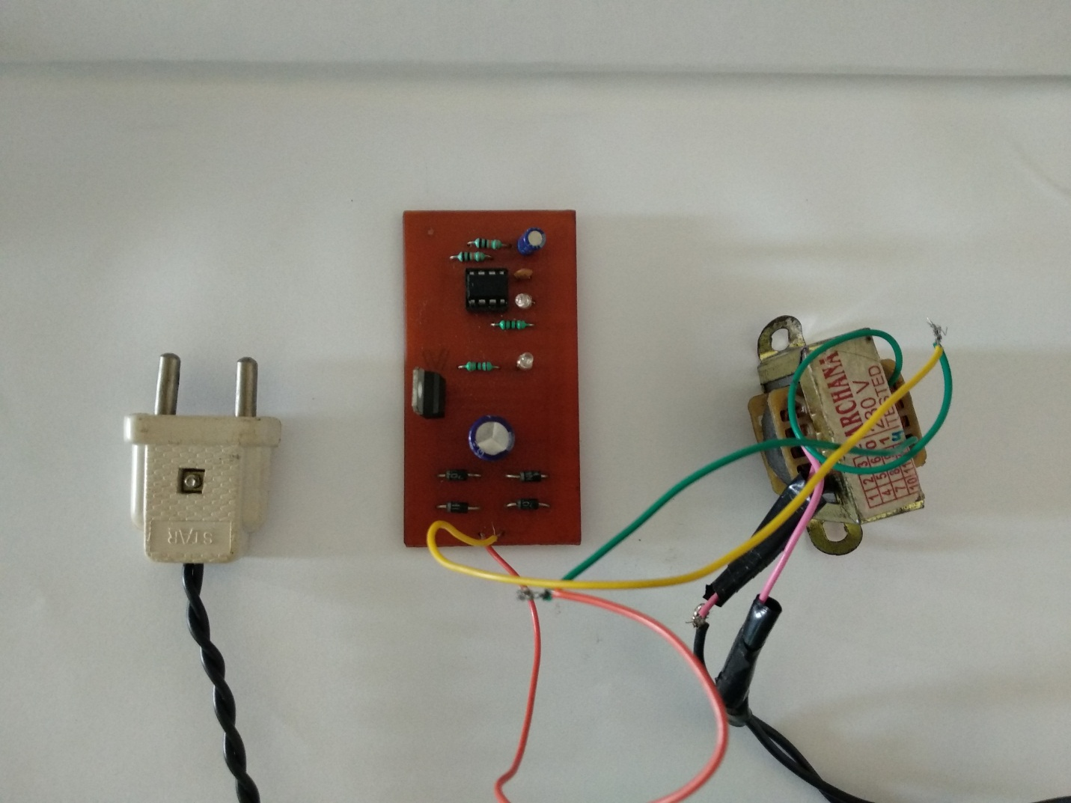

**Fig 8.1.1.** B**ulding of power supply**

A powersupply is an electrical device which supplies [power](https://en.wikipedia.org/wiki/Electric_power) in the form electric. The primary work of a power supply is to convert [electric current](https://en.wikipedia.org/wiki/Electric_current)  to  [voltage](https://en.wikipedia.org/wiki/Voltage), [current](https://en.wikipedia.org/wiki/Electric_current), and [frequency](https://en.wikipedia.org/wiki/Frequency) to power the load. As the result of power supplies is most of time referring to as [electric power converters](https://en.wikipedia.org/wiki/Electric_power_converter). Some power supplies have separate standalone pieces of equipment, while others are built into the load appliances. For example power supply found in number of personal computers and [their electronics](https://en.wikipedia.org/wiki/Consumer_electronics) devices. Another functions of power supply may perform include limiting the current which is drawn by the load to safe levels, shutting off the current in the event of an [electrical fault](https://en.wikipedia.org/wiki/Electrical_fault), power conditioning to prevent [electronic noise](https://en.wikipedia.org/wiki/Electronic_noise) on the input from  [power-factor correction](https://en.wikipedia.org/wiki/Power-factor_correction), and storing energy. So it can continue to power the load in the event of a temporary interruption in the source power.

The suitability of a particular power supply for an application is determined by various attributes of the power supply .Commonly specified attributes for a power supply include:

* Type of Input voltage AC or DC and range.
* Efficiency of power conversion.
* The amount of [voltage](https://en.wikipedia.org/wiki/Voltage) and [current](https://en.wikipedia.org/wiki/Current_(electricity))  supplied by power supply to its load
* Accuracy in output of power supply.
* Stability of output voltage and current which goes on under varying line and load conditions.
* How long it can supply energy without refueling or recharging.
* Operating and storage temperature ranges.

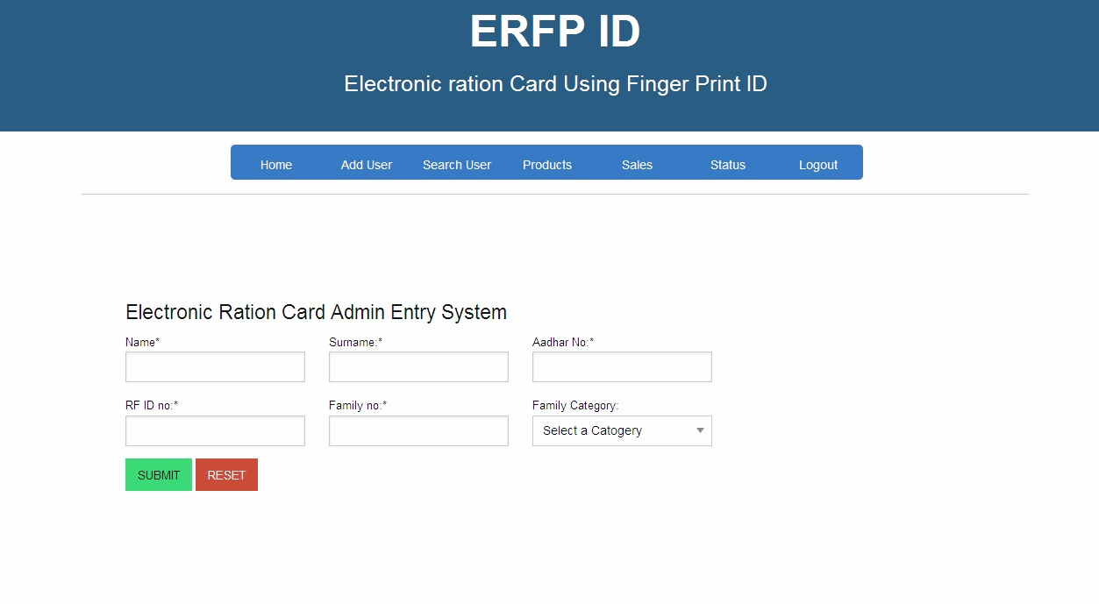

**Fig 8.1.3 Add User**

Traditionally State government of India provides a hard copy of Ration card. This approach has led to malpractices by the owners of PDS shops. Hence to overcome this this system uses online biometric verification of the end user.

The users fingerprint along with family details like total family members and poverty line details. These details are stored in the database and services are sorted based on poverty line.

The end user can only avails the services after verification of the fingerprint with the one stored in the database hence preventing frauds from the dealers.

A user first provides his/her family identification number based on this, respected family details are shown on the screen with all family member details using this any one member can avail services for the family.

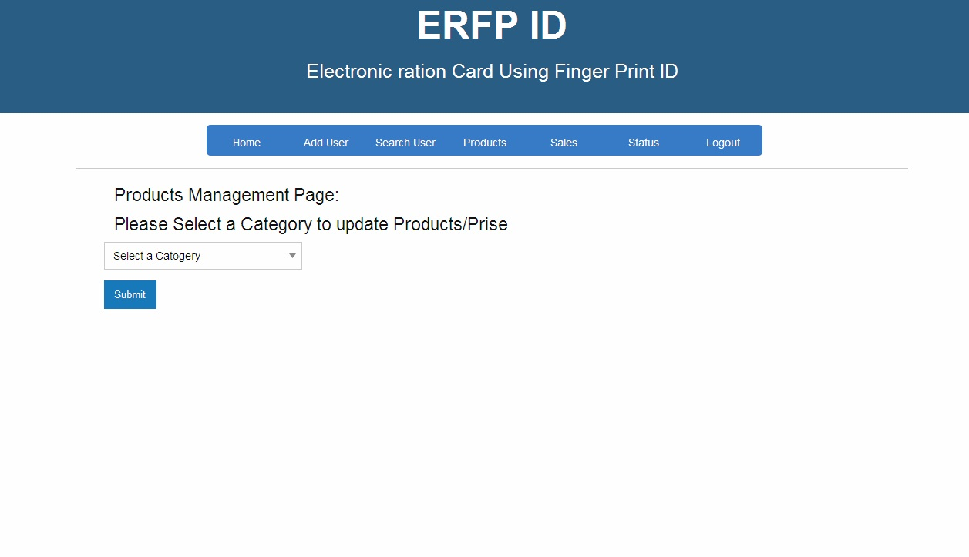

**Fig 8.1.4 Product Management page**

This system works with dynamic databases and is stored in a web server for that we have used XAMPP Server. It holds all the required software and web configurations required for the communication between Administrator server and Distributor PC.

This system shows that when this system is employed overall fraud cases can be eliminated and expected services can be given to the end user without any corruption.

**A. Web Server**

This system works with dynamic databases and is stored in a web server for that we have used XAMPP Server. It holds all the required software and web configurations required for the communication between Administrator server and Distributor PC.

**B. Database**

For storing user’s data and fingerprint details this system uses a MySQL Database in our system. This contains all the required tables for storing the user’s information and fingerprint data.

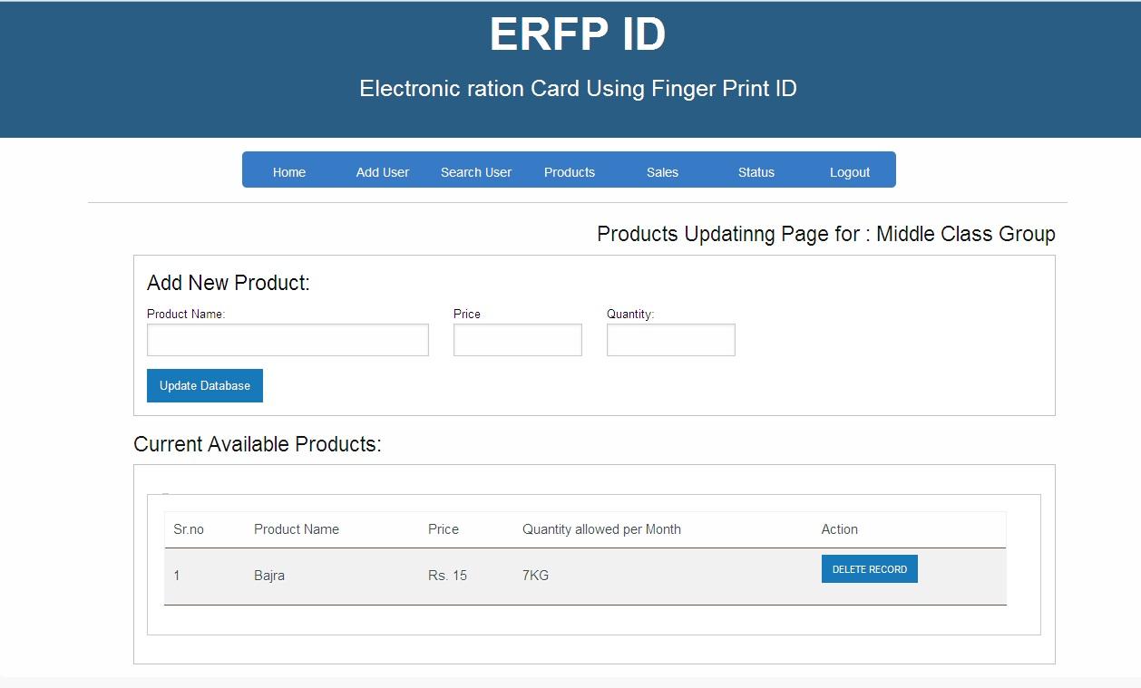

**Fig 8.1.4 Addition of new product**

This approach has led to malpractices by the owners of PDS shops. Hence to overcome this this system uses online biometric verification of the end user.

The users fingerprint along with family details like total family members and poverty line details. These details are stored in the database and services are sorted based on poverty line.

The end user can only avails the services after verification of the fingerprint with the one stored in the database hence preventing frauds from the dealers.

**Chapter 09**

**Conclusion**

Advantages and Applications

Advantages:

1. If this system becomes automated, corruption in government as well as market sector can be prevented.

2. Increased robbery in consumables can be prevented.

3. Price hike can be prevented.

4. It is cost effective approach and also save time.

5. The amount of time saved in monitoring and the number of trips done otherwise

Would be tremendous.

6. The financial aspect is the best advantage. This technology could replace humane

who are in change of monitoring and maintaining supplies.

Applications:

1. We can replace our traditional Public Distribution system using this

Smart Public Distribution System. Government authorized shops.

**Conclusion:**

This system shows that when this system is employed overall fraud cases can be eliminated and expected services can be given to the end user without any corruption.

The proposed system can provide efficient and secure way of public distribution.

Here we tested and implemented electronic ration cards instead of ration cards. In conventional system there is a chance for illegal activities such as marketing wrong entries without knowledge of card holder. If they do not buy material at the end of the month they lose their grains and kerosene this can be solved by our project by automatically update the account of the customer after every withdrawing of grains and kerosene. This system is used for real time applications.

REFERENCES

[1] Peter Svedberg; “Reforming or Replacing the Public Distribution System with cash transfers”, October 2012,.esocialsciences

[2] Rajneesh Mahajan. “Bar-coded Ration card public Distribution System”. 13th July 2012. INTERNATIONAL JOURNAL OF INNOVATIVE RESEARCH IN ELECTRICAL, ELECTRONICS, INSTRUMENTATION AND CONTROL ENGINEERING Vol. 1, Issue 8, November 2013

[3] Hemand Sharma, “UID and PDS system” , December 2012. International Research Journal of Engineering and Technology (IRJET), e-ISSN: 2395 -0056, p-ISSN: 2395-0072, Volume: 03 Issue: 03 | Mar-2016

[4] National Food Security Act. 12 September 2013. Enacted by : Parliament of India.

[5] Authors:Yogesh Kumar Sharma,K B Shiva Kumar.” Multi-Modality Biometric Assisted Smart card Based Ration Distribution system”. International Journal of Application or Innovation in Engineering & Management (IJAIEM), Volume 3, Issue 6, June 2014, ISSN 2319 – 4847.

[6]Authors: Shivabhakt Hanamant,Suraj V.S.Moresh Mukhedkar. “Automization of Rationing System”. International Journal of Advance Research, Ideas and Innovations in Technology. Volume 4, Issue 2 ISSN: 2454-132X

[7] Authors:S.Valarmathy,R.Ramani,Fahim Akhatar, “Automatic Ration Material Distribution Based On GSM and RFID Technology”. I.J. Intelligent Systems and Applications, 2013, 11, 47-54

[8] Pravada P. Wankhade and Prof. S. O. Dahad, ”Real Time Vehicle locking and Tracking System using GSM and GPS Technology-An Anti-theft System”, International Journal of Technology and Engineering System (IJTES): Jan March, 2011

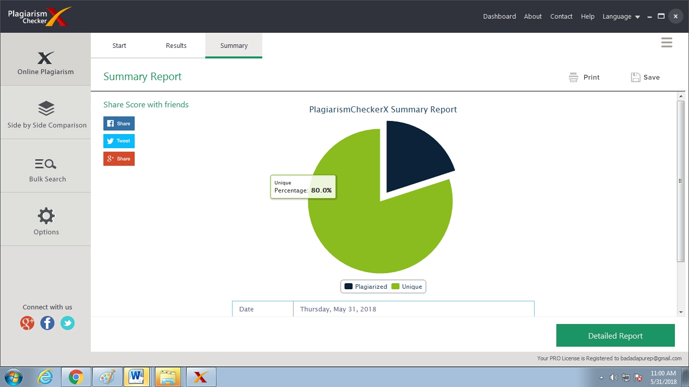

PLAGARISED REPORT WITH 80%

PUBLICATION

# ELECTRONIC RATION CARD WITH FINGER PRINT AUTHENTICATION

**Ramanjel Bhosale1,Deepak Dhage2, Pallavi Thite3 ,Pravinkumar Badadapure4**

***1,2,3*** *Dept. of Electronics and Telecommunication, JSPM’s Imperial College of Engineering and Research Wagholi, Pune, Maharastra 412207, India.*

*4 Professor, Dept. of Electronics and Telecommunication, JSPM’s Imperial College of Engineering and Research Wagholi, Pune, Maharastra 412207, India.*

***-----------------------------------------------------------------***­­­---------------------------------------------------------------------***

**Abstract–** *This paper describes the new and modern approach to the delivery of quality food and grain to the Indian population with the help of Electronic Ration card and how we can manage the Database Digitally with the help of DBMS. This modern approach is developed to avoid the frauds and to deliver the quality food stuffs to the citizens of India. We have achieved in the convenient way with the help of finger print authentication and by storing these records in Database.*

***Key Words: Digital Persona 4500, MySQL, PHP, JavaScript.***

**1. INTRODUCTION**

The Indian government provides number of food stuffs to their citizens in miserable rates to full fill the requirement of food in remote areas also, toprovide the wealth and to eradicate famine starvation. An official document provided by the state governments in India to the families that are eligible to purchase food grains at subsidized rates.

These food grains are delivered to the families with the help of PDS (public Distribution system)

There are three types of ration cards issued by the government are :

1. APL (Above Poverty Line )
2. BPL (Below poverty Line )
3. AAY (Antyodaya)

These are provided by the priority, defined by the National Food Security Act[4]. There are many problems with conventional PDS systems like millions of ineligible and fraud ration cards gets the benefits; at the same time there are many poor families having no Ration Cards.

Shop owners divert rationing grains to open market. To overcome such frauds and black market practices. We have designed Electronic Ration Card with Finger Print Authentication.

In this project work, we have to take the fingerprints of every member of ration card holder family. By collecting this data we can monitor the need of food grains of every family according to number of family members. By using this huge collection of data, we can call it as a big data we can analyze the need of grains and other food stuffs of the nation and according to this we can import or export the agricultural outcomes. The data we have gathered can be used to implement number of policies and schemes to eradicate the poverty.

**2**. **METHODOLOGY**

We have used online biometric verification. With the help of online webpage we have collected the data and stored this data in database for future transactions.

Fingerprint scanners:

By using this biometric tool, the main aim is to identify every person uniquely. As every human has a unique finger print pattern. As these fingerprints cannot be altered, they are specific to only one person.

There are four types of fingerprint scanners:

1. Capacitance scanner.
2. Optical scanner.
3. Ultrasonic fingerprint scanner
4. Thermal scanners.

We have used Optical Scanner which captures photos using digital camera and matches with the one in database, by comparing two instances of skin impression. Fingerprint identification is also known as Dactyloscopy.

Traditionally State government of India provides a hard copy of Ration card. This approach has led to malpractices by the owners of PDS shops. Hence to overcome this this system uses online biometric verification of the end user.

The users fingerprint along with family details like total family members and poverty line details. These details are stored in the database and services are sorted based on poverty line.

The end user can only avails the services after verification of the fingerprint with the one stored in the database hence preventing frauds from the dealers.

**3. System Description**

In this project there are two systems one Administrator and Distributor. Administrator section is used for addition/removal, updating user details and granting services. Distributor section is used for availing the services with fingerprint authentication system.

A user first provides his/her family identification number based on this, respected family details are shown on the screen with all family member details using this any one member can avail services for the family.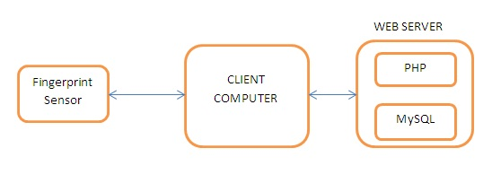

**Fig. 1 System architecture**



Fig 2. Database Architecture

**4. System Hardware & software design**

This system is divided into two sections hardware system and software system.

**4.1 System Hardware Design**

**A. Fingerprint Scanner**

This system is equipped with Digital Persona 4500 fingerprint scanner. It is a high performance optical scanner with 512dpi pixel resolution, 14.6mm scan capture area, 8bit grayscale, 65mm x 36mm x 15.56mm reader size.

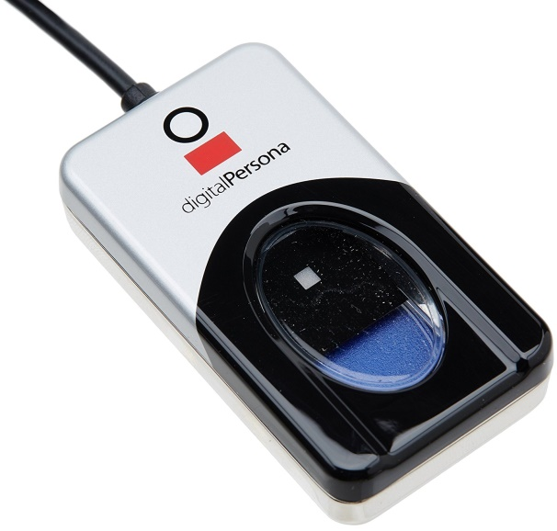

Fig.3 Digital Persona 4500

**4.2 Software design**

**A. Web Server**

This system works with dynamic databases and is stored in a web server for that we have used XAMPP Server. It holds all the required software and web configurations required for the communication between Administrator server and Distributor PC.



Fig 4. XAMPP Server

**B. Database**

For storing user’s data and fingerprint details this system uses a MySQL Database in our system. This contains all the required tables for storing the user’s information and fingerprint data.

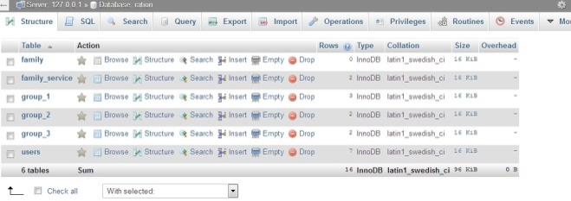

Fig 5. Database

**5. Conclusion :**

This system shows that when this system is employed overall fraud cases can be eliminated and expected services can be given to the end user without any corruption.

**REFERENCES**

[1] Peter Svedberg; “Reforming or Replacing the Public Distribution System with cash transfers”, October 2012

[2] Rajneesh Mahajan “Bar-coded Ration card public Distribution System” 13th July 2012

[3] Hemand Sharma, “UID and PDS system” , December 2012.

[4] National Food Security Act.

